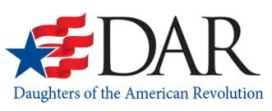
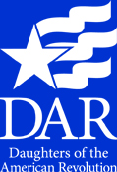
Ages of dependent children (note those who may be attending college at the same time as applicant:

Other sources of income or financial aid:

Scholarship Application Deadline: January 31, 2024

Scholarship Applicant Name (first, middle, last): ________________________________________________

FATHER or GUARDIAN or SELF | MOTHER or GUARDIAN or SPOUSE
NAME: | NAME:
ADDRESS: | ADDRESS:
POSITION/JOB: | POSITION/JOB:
ANNUAL INCOME: | ANNUAL INCOME:

(Non-married students, independent of parents, substitute self in place of father at the top of form and in student section below) (Married students, substitute spouse/self in place of mother and so indicate)

of Applicant
Colorado State Society
Daughters of the American Revolution
State Scholarship Financial
Need Form

The parent/guardian or applicant shall prepare a statement summarizing their family’s obligations and resources. The statement needs to illustrate the applicant’s need for financial assistance.

I attest that all information in this application and all attachments are a true and accurate record.

_________________________ __________________________ _______________________
Signature of Father or Guardian Signature of Mother or Guardian Signature of Applicant

